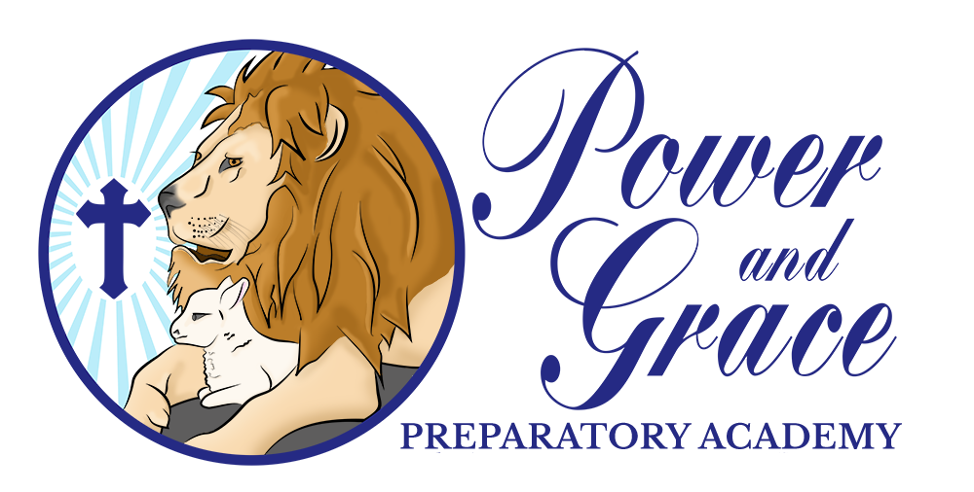

**Pre-Kindergarten 3 Supply List**

* Pencil box
* 3 Packs of Tab Dividers (8)
* 4 Chubby Pencils
* 2 8 oz Hand Soap and Hand Sanitizer
* 2 Boxes of Tissue
* 2 Boxes of Jumbo Crayons -

(8 Count-Crayola)

* 3 Packs of Refillable Wipes
* 2 Rest Towels. (No Blankets/ Beach Styles)
* 3 Packs of Copy paper
* 1 Large Backpack
* 2 Boxes of Ziploc Baggies (Gallon and Quart size)
* 1 Pack of Colored Construction Paper
* 2-3 Containers of Clorox Disinfecting Wipes
* 2 Pairs of School Uniforms for Accidents
* 2 Can of Spray Lysol

Required in January 

* 2 Packs of Copy Paper
* 2 Boxes of Tissue
* 2 Container of Clorox Disinfecting Wipes
* 1 Bottle of 8 oz Hand Soap and Hand Sanitizer
* 1 Can of Spray Lysol